
LIFE MEMBER AWARD NOMINATION
Queensland State Emergency Service

Part One – Nominee details
Surname: |  |  |  |  | First names:
Member No.: |  | Rank/position: |  |  |  |  | Date of birth:
Region: | FNR |  | NR | CEN | NCR | BNE | SER | SWR
Group:

Part Two – Eligible service dates (Exact dates are required. If applicable, Statement of Service from Interstate SES are required)
SES Service Calculation (Please refer to page 5 for further instruction)
Part Three – Justification (Additional information can be attached to this application)
High level of contribution demonstrated to training and operations, including hours and quality of operational activity. (i.e. how involved has the nominee been within the SES)

Significant achievements within SES and externally. (i.e. has the nominee received any awards)

General demeanour, attitude and behavioural history. (i.e. how has the nominee affected other members)

Participating actively in community engagement and commitment to the community. (i.e. how involved has the nominee been within the community)

 | PUBLIC | Page 1 of 5
This document is maintained in electronic form. The approved version of this document is located on the QFES Website and is uncontrolled when printed. It is the responsibility of the user to verify this copy is the latest version.
Involvement in the wider body, e.g. Queensland Fire and Emergency Services (QFES), Queensland Police Service, relevant Local Government/s. (i.e. how involved has the nominee been overall)

Overall distinguished levels of services. (i.e. overall has the nominee performed their duties with distinction)

Outstanding initiatives by a SES member to increase Member recruitment, public awareness of the SES, and/or Group/Unit effectiveness. (i.e. has the nominee been actively involved in strategies and/or actions for the betterment/advancement of SES)

Other justification for consideration.

Part Four – Nominating officer declaration and Area Office Recommendation
To the best of my knowledge, the nominee meets the eligibility criteria as outlined in SES Life Member Award Procedure.
Name: |  | Position:
Email: |  | Contact:
Signed: |  | Date:

Supported by Local Controller
Name: |  | Unit
Email: |  | Contact:
Signed: |  | Date:
Recommended by Area Controller
Name: |  | Area
Email: |  | Contact:
Signed: |  | Date:

 | PUBLIC | Page 2 of 5
This document is maintained in electronic form. The approved version of this document is located on the QFES Website and is uncontrolled when printed. It is the responsibility of the user to verify this copy is the latest version.

Part Five – Regional Office Endorsement
To be completed by SES Regional Support Officer:
Print “VIMS Detailed Member” Report attached
If required, SES interstate service supporting documentation provided
SES service period verified (please use SES service calculation)
Due diligence check (i.e. contentious issue etc)
Name: |  | Position
Email: |  | Contact:
Signed: |  | Date:
Regional Manager/Director Endorsement
Name: |  | Position
Email: |  | Contact:
Signed: |  | Date:

Part Six – SES State Office
Performance and Integrity Checks (i.e. ESU/ERU/SES Director Checks)
Supporting documents attached
Nomination form signed and completed
Name: |  | Position
Email: |  | Contact:
Signed: |  | Date:
Comments

 | PUBLIC | Page 3 of 5
This document is maintained in electronic form. The approved version of this document is located on the QFES Website and is uncontrolled when printed. It is the responsibility of the user to verify this copy is the latest version.

Part Seven – Volunteer Consultative Committee (VCC) Decision
Nomination Received Date:
Liaise with:
Group Leader Date:
Outcome/Notes:
Local Controller Date:
Outcome/Notes:
Local Controller Date:
Outcome/Notes:
Area Controller Date:
Outcome/Notes:
Regional Manager Date:
Outcome/Notes:
Other Comments
VCC Recommendation for SES Life Member Award: Yes No
Comments
Name: |  | Position
Email: |  | Contact:
Signed: |  | Date:

 | PUBLIC | Page 4 of 5
This document is maintained in electronic form. The approved version of this document is located on the QFES Website and is uncontrolled when printed. It is the responsibility of the user to verify this copy is the latest version.

Part Eight – Assistant Commissioner Endorsement
I endorse SES Life Member Award nomination and declare the years of service and all eligibility criteria have been validated.
I do not endorse SES Life Member Award nomination.

Name: |  | Position
Email: |  | Contact:
Signed: |  | Date:
Comments
Queensland Fire and Emergency Services is collecting personal information for the purpose of processing nominations subject to the requirements of the Information Privacy Act 2009 (the IP Act) which are defined in the 11 Information Privacy Principles (IPPs). For information on the 11 IPPs, refer to Schedule 3 of the IP Act.

Statement of Eligible Service

Any nominee using SES service from interstate is required to provide a supporting statement from that organisation when submitting a nomination. Statement is required to state eligible service dates.

How to use SES Service calculation

Double click SES Service table and type start and finish dates; When finish typing dates, select other section; or
Right Click on SES Service table, Select Worksheet Object and Open then type start and finish dates. Close the spreadsheet. Dates information should be updated.

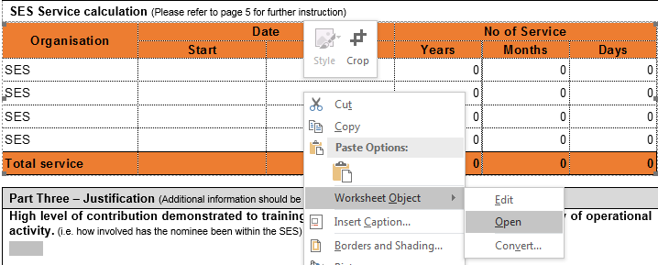

 | PUBLIC | Page 5 of 5
This document is maintained in electronic form. The approved version of this document is located on the QFES Website and is uncontrolled when printed. It is the responsibility of the user to verify this copy is the latest version.

