Emergency Evacuation Procedure
Premises Name

In case of
Fire or Other Emergency

- If you see SMOKE, FLAMES or hear the FIRE ALARM, alert other occupants immediately.
- If safe, close any windows and doors to confine the fire.
- Follow the EXIT signs to locate and leave through the emergency exit and proceed down the fire stairs to the assembly area located in the rear car park.
- TELEPHONE 000 and notify the fire service.
- Calmly follow instructions given by staff or the attending Fire Officers.


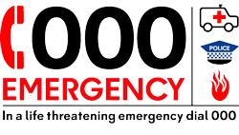
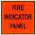

In an emergency dial 000

EXIT
ASSEMBLY AREA

PATH OF EXIT
EXTINGUISHER
FIRE HOSE REEL
FIRE INDICATOR PANEL
ALTERNATE PATH
MANUAL CALL POINT
AA
YOU ARE HERE
AA

