**Bushfire Resilient Communities MapViewer**

User Guide

January 2025

Contents

About the Bushfire Resilient Communities (BRC) MapViewer 2

BRC MapViewer Disclaimer 2

What maps and products are available in the BRC MapViewer 3

Interpreting Bushfire Prone Area Mapping in the BRC MapViewer 3

Vegetation Hazard Class (VHC) Mapping in the BRC MapViewer 3

Vegetation layers in the BRC MapViewer 4

Forest Fire Danger Index (FFDI) Mapping in the BRC MapViewer 5

Navigating in the BRC MapViewer 6

Key Features 7

Using Map Layers and Legend 7

Map Legend 8

Changing the Basemap 8

How to Search for your Property 10

Searching by lot and plan or property address 10

How To Use MapViewer Tools 12

Selecting layers 12

Using the draw function 12

Draw a point, draw a polyline, draw a polygon, draw a rectangle, and Draw a circle 12

Using the measure function 13

Inserting a bookmark 14

Importing data into MapViewer 15

Search 16

URL 16

Printing a map 17

Troubleshooting 17

Layers Catalogue 18

References 18

## About the Bushfire Resilient Communities (BRC) MapViewer

The BRC MapViewer is an online tool developed for viewing and interrogating bushfire prone areas and supporting information across Queensland. The tool provides an interactive format to support users in better understanding bushfire hazard and provides mapping as well as additional information inputs including vegetation hazard class, fire weather severity, contours and other inputs that support technical users in undertaking a bushfire hazard assessment.

The BRC MapViewer is designed to support users in seeking information when interpreting and assessing bushfire hazard for planning purposes. It is intended to support town planning and environmental professionals, development proponents, bushfire consultants, bushfire hazard assessors, building certifiers with tools to apply technical information in the Bushfire Resilient Communities technical guide.

It is recommended that users familiarise themselves with the Bushfire Resilient Communities Technical Reference Guide (2019) prior to using the BRC MapViewer. For further information regarding the BRC technical guide, See [Bushfire resilient communities | Queensland Fire Department](https://www.fire.qld.gov.au/compliance-and-planning/bushfire-planning/brc)

### BRC MapViewer Disclaimer

The BRC MapViewer will open with the following disclaimer.

The BRC MapViewer is subject to the terms and conditions as detailed below.

* Queensland Fire Department (QFD) excludes all liability to any person arising directly or indirectly from using this site and any information or material available from it
* BRC MapViewer content is general in nature and independent professional advice should be sought relevant to your particular circumstances
* Content is subject to the uncertainties of scientific and technical research
* Mapping and bushfire hazard information may not be accurate, current or complete
* Mapping and bushfire hazard information is subject to change without notice
* Content may include the views or recommendations of third parties, which do not necessarily reflect the views of Queensland Fire Department (QFD) or indicate a commitment to a particular course of action
* The BRC MapViewer includes data supplied to the department by various external agencies and organisations. Those external agencies and organisations retain the respective ownership and intellectual property rights in the data supplied, where relevant
* The contents of the BRC MapViewer (which includes downloadable material) are subject to copyright and are protected by laws of Australia and other countries through international treaties
* The BRC MapViewer tool includes data to spatially represent and support the assessment of matters of state interest as expressed in the State Planning Policy 2017. Mapping may be updated from time to time and users should consult the IMS and DAMs Mapping. For further information see [Mapping | Planning](https://www.planning.qld.gov.au/planning-framework/mapping)

## What maps and products are available in the BRC MapViewer

The BRC MapViewer contains several products that assist users with understanding bushfire hazard. These include.

* Bushfire prone area
* Vegetation hazard class
* Vegetation layers including regional ecosystems, remnant vegetation, high value regrowth and pre-clear mapping
* Contour mapping (1m, 3m and 5m)
* Maximum landscape slope
* Forest Fire Danger Index (FFDI)
* Administrative, cadastre and other layers necessary for bushfire assessment

### Interpreting Bushfire Prone Area Mapping in the BRC MapViewer

Bushfire prone area (BPA) is defined in the State Planning Policy (SPP) as:

‘land that is potentially affected by significant bushfires, including vegetation likely to support a significant bushfire; adjacent land that could be subject to impacts from a significant bushfire (i.e. potential impact buffer) and is:

1. identified by a local government in a local planning instrument as a bushfire prone area, based on a localised bushfire study, prepared by a suitably qualified person; or
2. if the local government has not identified bushfire prone areas in a local planning instrument in accordance with (a) above, shown on the SPP interactive mapping system (IMS) as a bushfire prone area.’

The following table provides an outline of the classes within the BPA layers.

|  |  |  |  |
| --- | --- | --- | --- |
| Region | Bushfire Hazard Class | Fireline Intensity | Class (as displayed in the BRC MapViewer) |
|  |  |  |  |
| All regions of Queensland | Very High Potential Bushfire Intensity | 40,000+ kW/m |  |
| High Potential Bushfire Intensity | 20,000 – 40,000 kW/m |  |
| Medium Potential Bushfire Intensity | 4,000 – 20,000 kW/m |  |
| Potential Impact Buffer | 100 metre linear distance that indicates the distance from vegetation that can still impact people and structures from the impacts of bushfire attack. |  |

### Vegetation Hazard Class (VHC) Mapping in the BRC MapViewer

VHC mapping represents long term vegetation structure, floristic and fuel parameters which are key determinants of fire behaviour and fireline intensity.

* Vegetation Hazard Class – Applicable to all regions.

Due to the map smoothing process, some areas of vegetation may appear pixilated, and others may appear smoothed. Mapping layers are colour coded by the Broad vegetation Group (BVG) (see below).

|  |
| --- |
|  |
| *Example BVG map display as distinct colours* |

Each BVG (coloured area) may contain one or multiple VHC codes (i.e. 16.2). To identify the VHC, select the area to be investigated. The area will highlight with a text box appearing displaying the VHC code.

|  |  |
| --- | --- |
|  |  |
|  | |
| *Examples from BRC MapViewer of a single BVG (9.15) containing two different VHC’s (9.1 and 10.10)* | |

The VHC code aligns with a specific Vegetation Hazard Class as identified in the Bushfire Resilient Communities guidance (excerpt below).

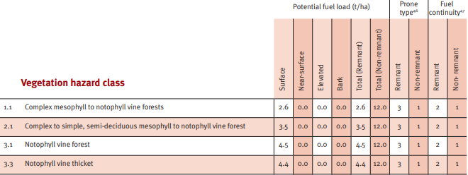

*Excerpt from VHC Table, Bushfire Resilient Communities technical reference guide.*

In certain instances, accuracy of the VHC mapping may be insufficient. Where this has occurred, please consult the Bushfire Resilient Communities technical reference guidance regarding undertaking a localised site assessment to verify Vegetation Hazard Class.

### Vegetation layers in the BRC MapViewer

The BRC MapViewer includes several vegetation layers produced by the Queensland Herbarium. These layers are included to assist users in undertaking a localised bushfire hazard assessment.

The BRC includes remnant vegetation, high value regrowth and pre-clear extent. The map also includes the regional ecosystem description label (i.e. 12.8.16) to allow users to look up regional ecosystem descriptions available through the [Regional ecosystem descriptions | Environment, land and water | Queensland Government (www.qld.gov.au)](https://www.qld.gov.au/environment/plants-animals/plants/ecosystems/descriptions)

|  |  |
| --- | --- |
|  |  |

*Example of display of remnant vegetation, regional ecosystem description label and except of metadata.*

Users can select specific areas to access further information including vegetation management status, percentage cover and biodiversity status.

To find out more information about Vegetation layers and other products produced by the Queensland Herbarium, see [Regional ecosystems | Environment, land and water | Queensland Government (www.qld.gov.au)](https://www.qld.gov.au/environment/plants-animals/plants/ecosystems)

To request a property report and vegetation map, see Request a free vegetation management report or map | Environment, land and water | Queensland Government (www.qld.gov.au)

### Forest Fire Danger Index (FFDI) Mapping in the BRC MapViewer

Forest Fire Danger Index (FFDI) is a well-known proxy of fire weather severity which has been used as an input to 2014 and 2017 BPA mapping for Queensland using models prepared by CSIRO.

While new methods have been developed to reflect fire weather severity to generate 2024 BPA mapping which is aligned to AFDRS fire behavior models, FFDI is still relevant to bushfire hazard assessments, emergency management and in standards such as the Australian Standard *AS3959–2018 Construction of buildings in bushfire-prone areas.*

Equivalent to the McArthur Forest Fire Danger Index (FFDI), a 1-in-20 year FFDI value reflecting climate change to 2050 is included in the BRC MapViewer to be used as an indicator of fire weather severity for the assessment area. The FFDI values utilise data modelled by CSIRO for Queensland under the A1FI emissions scenario to the year 2050 (Leonard et al. 2014).

FFDI is displayed as a series of contours in the BRC MapViewer. To find out the FFDI value, click on the selected area A new window will open containing details including FFDI for the highlighted band.

|  |  |  |
| --- | --- | --- |
|  |  |  |
| *Excerpt from the BRC MapViewer* | |  |

## Navigating in the BRC MapViewer

The BRC MapViewer will open with a home screen. The following features will be visible.

* Information pane
* Navigation buttons
* Viewing window
* Toolbox
* Scale bar, latitude and longitude
* Full screen button

Navigation buttons

Viewing Window

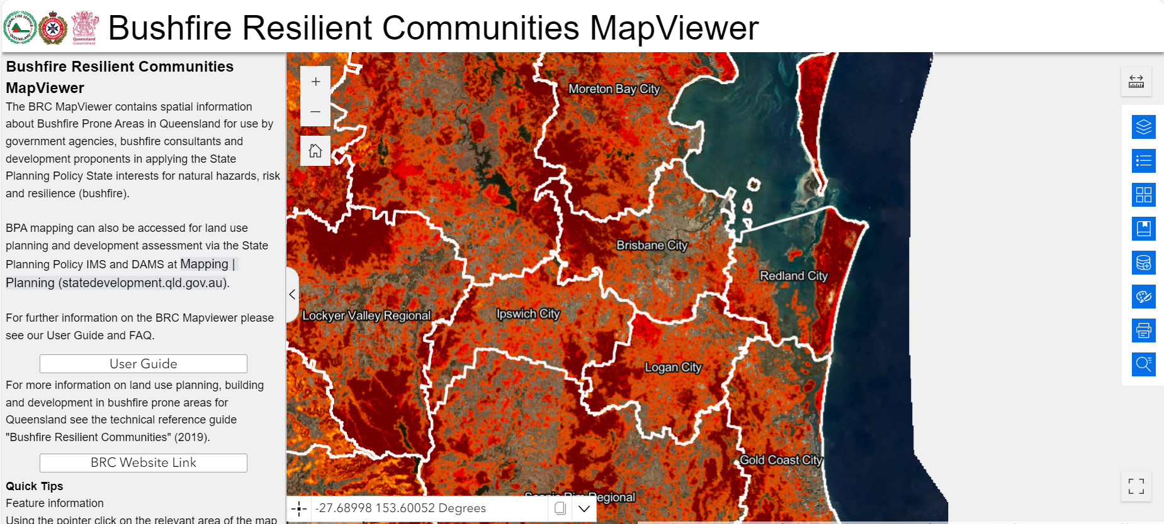

Toolbox

Scale bar latitude and longitude

Information pane

Full screen button

|  |  |
| --- | --- |
| The BRC is navigated by clicking and panning. Use of the Home button will return the map to the original state-wide scale. |  |
| You can zoom in and out by using the mouse scroll function or by using the Plus and Minus buttons |  |
| The full screen button will expand the map to the full extent of your screen. Note: If the side bar is open on the left this will close and cannot be accessed in full screen mode. To return to regular view or to see the sidebar use the same button again to close out of full screen mode. |  |

## Key Features

|  |  |  |  |
| --- | --- | --- | --- |
|  | | | |
| The BRC MapViewer has a variety of tools available for use. To access these tools, click on one of the blue icons in the panel located on the right-hand side of the map.  The tool window can be adjusted in size using the lower right corner to resize. To move this tool-window, move the pointer over the title banner and the move cursor will appear allowing the window to be moved.  The BRC MapViewer includes the following tools in the toolbar. |  | **Map layers** |  |
| **Map legend** |  |
| **Basemap selector** |  |
| **Bookmark** |  |
| **Add data** |  |
| **Draw** |  |
| **Print** |  |
| **Search** |  |

### Using Map Layers and Legend

|  |  |
| --- | --- |
| Map layers are available in the viewer and can be accessed by clicking the Map Layers icon. This will open the layer table of contents, listing the available data as shown below. |  |

|  |  |
| --- | --- |
|  | You can interact with the Map Layers’ table of contents by using the arrows to open the sub folders of layers. Use the clickable squares to switch layer visibility on and off. |
|  | To display the legend for visible layers click on the three lines. |
|  | To increase or decrease the layer’s transparency click on the three dots. |

### Map Legend

|  |  |
| --- | --- |
| The symbology associated with the visible map layers in the viewer are accessed by clicking the Legend icon. This will open the Legend tool window, listing the symbology as shown below. |  |

### Changing the Basemap

|  |  |  |
| --- | --- | --- |
| Various basemaps can be accessed by clicking the Basemap Gallery icon. This will open the Basemap tool window, listing the available basemaps as shown below. | |  |
| The BRC MapViewer has two basemaps available, open street view and aerial photography. Aerial photography may not be up to date and ground truthing is always advised when reviewing vegetation cover. |  | |

## How to Search for your Property

### Searching by lot and plan or property address

|  |  |  |  |
| --- | --- | --- | --- |
| To search for an address or a lot/plan number use the Search tool which can be accessed by clicking the Search icon. This will open the Search tool window. | | |  |
| Type in the search box and press Enter, click the search button, or choose from a list of suggestions that appear based on matching records. |  |  | |

If searching using a Lot/Plan, click on your search result and the popup window will appear, use ‘zoom to’.

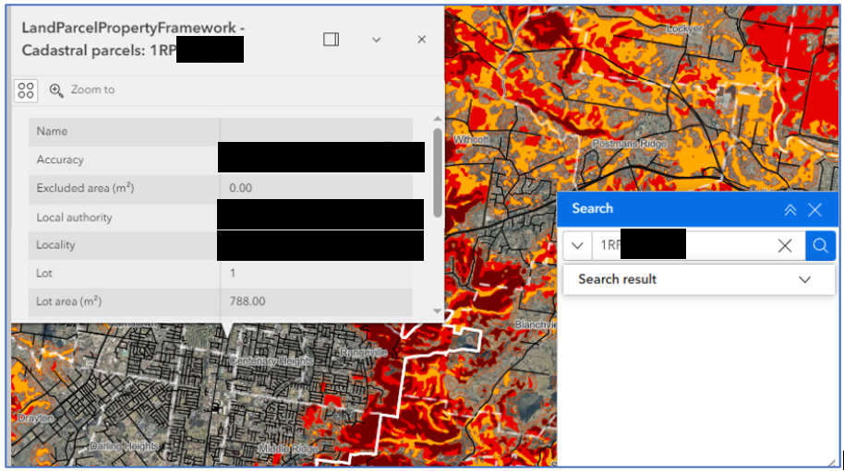

If searching using a street address, click on your search result and the map will automatically zoom to your address.

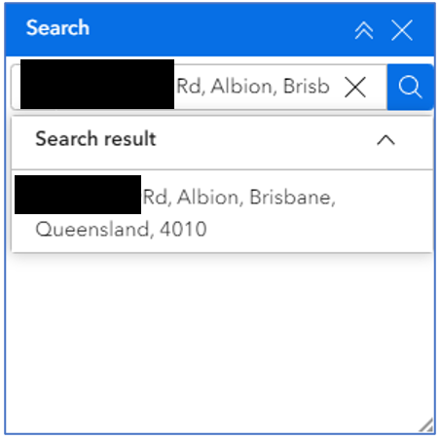

## How To Use MapViewer Tools

### Selecting layers

|  |  |
| --- | --- |
| Choose a method for selecting drawn features. Once a feature is drawn it can be selected using these options. Once selected, the feature can be named, deleted, duplicated, moved or resized. |  |

### Using the draw function

|  |  |  |  |
| --- | --- | --- | --- |
| There are many functions that can be completed using the Draw tool which can be accessed by clicking the Draw icon. This will open the Draw tool window. | | |  |
| Draw a point, draw a polyline, draw a polygon, draw a rectangle, and draw a circle Sketch a feature on the map. To finish sketching, double click. | |  | |
| View a preview of the symbology of the feature to be drawn. |  | | |

### Using the measure function

|  |  |  |
| --- | --- | --- |
| To measure a distance or an area use the Measure tool accessed by clicking the Measure icon. This will open the Measure tool window. | |  |
| To finish measuring double click. |  | |

### Inserting a bookmark

|  |  |
| --- | --- |
| The user can create their own bookmarks by using the Bookmark tool which can be accessed by clicking the Bookmark icon. This will open the Bookmark tool window. |  |

|  |  |
| --- | --- |
| To create a bookmark, ensure the map is situated in the location that you wish to bookmark.  Click the plus button and it will create a bookmark for that view. |  |
| It will be named Bookmark (#), to rename, click on the name and edit.  To use a bookmark to navigate to the bookmarked location, click on the bookmark and the map will zoom to your bookmarked location. |  |

## Importing data into MapViewer

|  |  |
| --- | --- |
| The user can add their own data by using the Add Data tool which can be accessed by clicking the Add Data icon. This will open the Add Data tool window. |  |

|  |  |
| --- | --- |
| There are three ways to add data; Search, URL and File. |  |

|  |  |  |  |
| --- | --- | --- | --- |
| **Search** | **URL** | | **File** |
|  |  | |  |
| Search Search for content stored as ArcGIS items. You can browse and search for data sources in your content, your groups, your organisations, and content that is shared publicly, including ArcGIS Living Atlas of the World. The tool supports [advanced keyword search](https://doc.arcgis.com/en/arcgis-online/reference/advanced-search.htm) to narrow the results. You can also click the Type button to search for specific data types (such as feature layers, elevation layers, scene layers, and group layers).  **Note:** ArcGIS Living Atlas of the World includes three levels of content: publicly available content, [subscriber content, and premium content](https://doc.arcgis.com/en/arcgis-online/reference/faq.htm#ESRI_QUESTIONANSWER_974E2E21497F42FA9344B871F03CB6AF). Subscriber content, such as Landsat 8 imagery, requires an organisational subscription account to access. Premium content is subscriber content that consumes credits, such as demographic and lifestyle layers.  **Note:** Feature collections containing multiple layers appear in the Group Layer category when you filter by layer type. URL Add layers or web services by URL. The drop-down menu lists the types of data that you can add by URL. You must select the appropriate type to add data of that type by URL.  **Note:** You can add the data in the following formats by both Search and URL: feature service, map service, vector tile service, image service, scene service, KML, WFS, WMS, WMTS, GeoJSON, and CSV. | | | |
| Once the data is added, it will be listed in the window and it will automatically be added to the map and zoomed to. To delete this layer use the Trash Icon. | |  | |

## Printing a map

|  |  |  |  |  |
| --- | --- | --- | --- | --- |
| To print the current map view use the Print tool which can be accessed by clicking the Print icon. This will open the Print tool window. | | | |  |
| Here you can adjust various settings, including under the advanced tab. | | |  | |
|  |  | The printed files will appear under the tab Results. |  | |

## Troubleshooting

Please contact the Bushfire Resilient Communities unit at brc@fire.qld.gov.au with the subject line

'BRC MapViewer enquiry'.

## Layers Catalogue

|  |  |  |
| --- | --- | --- |
| Map Layers and Datasets | Currency | Availability |
| Bushfire |  |  |
| Bushfire Prone Area | 2014 and for SEQ 2017 | [Queensland Spatial Catalogue](https://qldspatial.information.qld.gov.au/catalogue/custom/detail.page?fid=%7b276BC86E-214A-42D2-87AD-161CD06C4020%7d) and  [Queensland Spatial Catalogue:SEQ](https://qldspatial.information.qld.gov.au/catalogue/custom/detail.page?fid=%7b8712BDE4-27D1-49A2-83F1-AE7A692B816D%7d) |
| Fire Weather Severity (FFDI 5% AEP) | 30 Jul 2014 | [Queensland Spatial Catalogue](https://qldspatial.information.qld.gov.au/catalogue/custom/detail.page?fid=%7b276BC86E-214A-42D2-87AD-161CD06C4020%7d) |
| Maximum Landscape Slope | 30 Jul 2014 | [Queensland Spatial Catalogue](https://qldspatial.information.qld.gov.au/catalogue/custom/detail.page?fid=%7b276BC86E-214A-42D2-87AD-161CD06C4020%7d) |
| Broad Vegetation Hazard Class | 2014 and for SEQ 2017 | [Queensland Spatial Catalogue](https://qldspatial.information.qld.gov.au/catalogue/custom/detail.page?fid=%7b14E905E9-0B0B-41D5-9CA7-C7E563AC69DF%7d) and  [Queensland Spatial Catalogue:SEQ](https://qldspatial.information.qld.gov.au/catalogue/custom/detail.page?fid={4E08C0FF-AF8D-4FA2-8DAD-050E787F47EB}) |
| Environment |  |  |
| Regional Ecosystems V13 (REM and HVR) | 15 May 2024 | [Queensland Spatial Catalogue](https://qldspatial.information.qld.gov.au/catalogue/custom/detail.page?fid=%7b8FDF54D2-654C-4822-8295-1D8E8E772373%7d) |
| Pre-clearing Vegetation V13 (Regional Ecosystems) | 15 May 2024 | [Queensland Spatial Catalogue](https://qldspatial.information.qld.gov.au/catalogue/custom/detail.page?fid=%7b22E1BC4E-BDFA-470A-AED8-04F38B4FCFC3%7d) |
| High-value Regrowth Vegetation | 15 May 2024 | [Queensland Spatial Catalogue](https://qldspatial.information.qld.gov.au/catalogue/custom/detail.page?fid=%7bAA49DD91-1D59-40C1-B9C7-BC472148B90E%7d) |
| Priority Agricultural Area | As needed | [Queensland Spatial Catalogue](https://spatial-gis.information.qld.gov.au/arcgis/rest/services/PlanningCadastre/AreasOfRegionalInterest/MapServer) |
| Priority Living Area | As needed | [Queensland Spatial Catalogue](https://spatial-gis.information.qld.gov.au/arcgis/rest/services/PlanningCadastre/AreasOfRegionalInterest/MapServer) |
| Strategic Environmental Area | As needed | [Queensland Spatial Catalogue](https://spatial-gis.information.qld.gov.au/arcgis/rest/services/PlanningCadastre/AreasOfRegionalInterest/MapServer) |
| Planning cadastre |  |  |
| Queensland Border | Updated as required | [Queensland Spatial Catalogue](https://spatial-gis.information.qld.gov.au/arcgis/rest/services/PlanningCadastre/LandParcelPropertyFramework/MapServer) |
| Local Government Area | Updated quarterly | [Queensland Spatial Catalogue](https://spatial-gis.information.qld.gov.au/arcgis/rest/services/PlanningCadastre/LandParcelPropertyFramework/MapServer) |
| Locality Boundaries | Updated quarterly | [Queensland Spatial Catalogue](https://spatial-gis.information.qld.gov.au/arcgis/rest/services/PlanningCadastre/LandParcelPropertyFramework/MapServer) |
| Postcode | Updated quarterly or as required | [Queensland Spatial Catalogue](https://spatial-gis.information.qld.gov.au/arcgis/rest/services/Boundaries/AdministrativeBoundaries/MapServer/3) |
| Federal electorate | Continual | [Queensland Spatial Catalogue](https://spatial-gis.information.qld.gov.au/arcgis/rest/services/Boundaries/AdministrativeBoundaries/MapServer/4) |
| State electorate | Continual | [Queensland Spatial Catalogue](https://spatial-gis.information.qld.gov.au/arcgis/rest/services/Boundaries/AdministrativeBoundaries/MapServer/5) |
| Local Government Division | Continual | [Queensland Spatial Catalogue](https://spatial-gis.information.qld.gov.au/arcgis/rest/services/Boundaries/AdministrativeBoundaries/MapServer/7) |
| Brisbane City Council Ward | Continual | [Queensland Spatial Catalogue](https://spatial-gis.information.qld.gov.au/arcgis/rest/services/Boundaries/AdministrativeBoundaries/MapServer/8) |
| Addresses | Updated nightly | [Queensland Spatial Catalogue](https://spatial-gis.information.qld.gov.au/arcgis/rest/services/PlanningCadastre/LandParcelPropertyFramework/MapServer) |
| Tenure | Updated nightly | [Queensland Spatial Catalogue](https://spatial-gis.information.qld.gov.au/arcgis/rest/services/PlanningCadastre/LandParcelPropertyFramework/MapServer) |
| Base Parcels Only | Updated nightly | [Queensland Spatial Catalogue](https://spatial-gis.information.qld.gov.au/arcgis/rest/services/PlanningCadastre/LandParcelPropertyFramework/MapServer) |
| Cadastral Natural Boundaries | Updated nightly | [Queensland Spatial Catalogue](https://spatial-gis.information.qld.gov.au/arcgis/rest/services/PlanningCadastre/LandParcelPropertyFramework/MapServer) |
| Cadastral Boundaries | Updated nightly | [Queensland Spatial Catalogue](https://spatial-gis.information.qld.gov.au/arcgis/rest/services/PlanningCadastre/LandParcelPropertyFramework/MapServer) |
| State Controlled Road | Updated quarterly | [Queensland Spatial Catalogue](https://spatial-gis.information.qld.gov.au/arcgis/rest/services/Transportation/StateRoadInformation/MapServer/6) |
| Roads and Tracks | Updated daily | [Queensland Spatial Catalogue](https://spatial-gis.information.qld.gov.au/arcgis/rest/services/Transportation/RoadsAndTracks/MapServer/10) |
| Elevation and Contours |  |  |
| Biogeographic Region | As needed | [Queensland Spatial Catalogue](https://spatial-gis.information.qld.gov.au/arcgis/rest/services/Boundaries/AdminBoundariesFramework/MapServer/2) |
| Built Up Area | As needed | [Queensland Spatial Catalogue](https://spatial-gis.information.qld.gov.au/arcgis/rest/services/Boundaries/AdminBoundariesFramework/MapServer/202) |
| Drainage Division | As needed | [Queensland Spatial Catalogue](https://spatial-gis.information.qld.gov.au/arcgis/rest/services/Boundaries/AdminBoundariesFramework/MapServer/5) |
| Drainage Basin Sub-Area | As needed | [Queensland Spatial Catalogue](https://spatial-gis.information.qld.gov.au/arcgis/rest/services/Boundaries/AdminBoundariesFramework/MapServer/5) |
| Drainage Basin | As needed | [Queensland Spatial Catalogue](https://spatial-gis.information.qld.gov.au/arcgis/rest/services/Boundaries/AdminBoundariesFramework/MapServer/5) |
| Contours | As needed | [Queensland Spatial Catalogue](https://spatial-gis.information.qld.gov.au/arcgis/rest/services/Elevation/Contours/MapServer) |

### References

Leonard, J., Opie, K., Newnham, G. and Blanchi, R., 2014. A new methodology for state-wide mapping of bushfire prone areas in Queensland. *Canberra, Australia: CSIRO*.