**Fire Safety Management Plan**

***Fire Services Act 1990,* Part 4**

**Template**



 Licence URL: <http://creativecommons.org/licenses/by/4.0/legalcode>

Please give attribution to © State of Queensland (Queensland Fire and Emergency Services) 2025

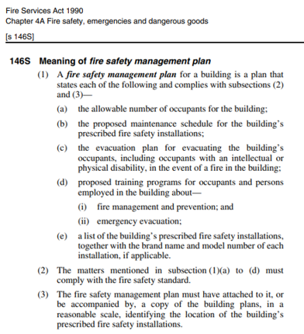Eva

|  |  |
| --- | --- |
| Building Information | |
| **Building Location & Name:** |  |
| **Building Owner:** |  |
| **Building Occupier:** |  |
| **Building Manager:** |  |
| **Building Construction:** |  |
| **Floor Area:** |  |

Plan

|  |  |  |  |  |
| --- | --- | --- | --- | --- |
| Allowable Number of Occupants | | | | |
| **Bedroom** | **Room Size** | **Area in m2** | **Max No of occupants (2.5m2/person)** | **900mm travel path**  **(Yes or No)** |
|  |  |  |  |  |
|  |  |  |  |  |
|  |  |  |  |  |
|  |  |  |  |  |
|  |  |  |  |  |
| **Total number of occupants:** | | |  |  |

|  |  |  |  |  |
| --- | --- | --- | --- | --- |
| Proposed Maintenance Schedule Prescribed Fire Safety Installations | | | | |
| **Installation** | **Start Date** | **Test** | **Frequency** | **Competent Person** |
|  |  |  |  |  |
|  |  |  |  |  |
|  |  |  |  |  |
|  |  |  |  |  |
|  |  |  |  |  |

|  |
| --- |
| A performance solution is used within this building to satisfy the Performance Criteria of the applicable building code. Details of the performance solution are: |
|  |

|  |
| --- |
| Fire and Evacuation Plan |

Delete this text box and insert here a copy of the relevant documents. See example at

[www.fire.qld.gov.au/sites/default/files/2021-05/Fire-safety-management-plan-example.pdf](http://www.fire.qld.gov.au/sites/default/files/2021-05/Fire-safety-management-plan-example.pdf)

|  |
| --- |
| Proposed Training Program |

## 

Delete this text box and insert here a copy of the proposed training program. See example at

[www.fire.qld.gov.au/sites/default/files/2021-05/Fire-safety-management-plan-example.pdf](http://www.fire.qld.gov.au/sites/default/files/2021-05/Fire-safety-management-plan-example.pdf)

|  |
| --- |
| List of Prescribed Fire Safety Installations |

|  |  |  |  |
| --- | --- | --- | --- |
| **Smoke Alarms - Installed in accordance with A1 of the Fire Safety Standard** | | | |
| Date installed | Installed by | Brand name | Model no. |
|  |  |  |  |

|  |  |  |  |
| --- | --- | --- | --- |
| **Emergency Lighting - Installed in accordance with A2 of the Fire Safety Standard** | | | |
| Date installed | Installed by | Brand name | Model no. |
|  |  |  |  |

|  |  |  |  |
| --- | --- | --- | --- |
| **Exit Signage - Installed in accordance with A7 of the Fire Safety Standard** | | | |
| Date installed | Installed by | Brand name | Model no. |
|  |  |  |  |

|  |  |  |  |
| --- | --- | --- | --- |
| **Fire Extinguishers - Installed in accordance with A8 of the Fire Safety Standard** | | | |
| Ext. no. | Date installed | Brand name | Extinguisher type |
|  |  |  |  |

|  |  |  |  |
| --- | --- | --- | --- |
| **Fire Hose Reels - Installed at the time of building construction** | | | |
| Date installed | Installed by | Brand name | Model no. |
|  |  |  |  |

|  |
| --- |
| Building Plans |

Delete this text box and insert here a copy of the building plans. See example at

[www.fire.qld.gov.au/sites/default/files/2021-05/Fire-safety-management-plan-example.pdf](http://www.fire.qld.gov.au/sites/default/files/2021-05/Fire-safety-management-plan-example.pdf)